**Project Design Phase-II**

**Technology Stack (Architecture & Stack)**

| Date | 03 October 2022 |
| --- | --- |
| Team ID | PNT2022TMID31851 |
| Project Name | Project - Visualizing and Predicting Heart Diseases with an Interactive Dashboard |
| Maximum Marks | 4 Marks |

**Technical Architecture:**

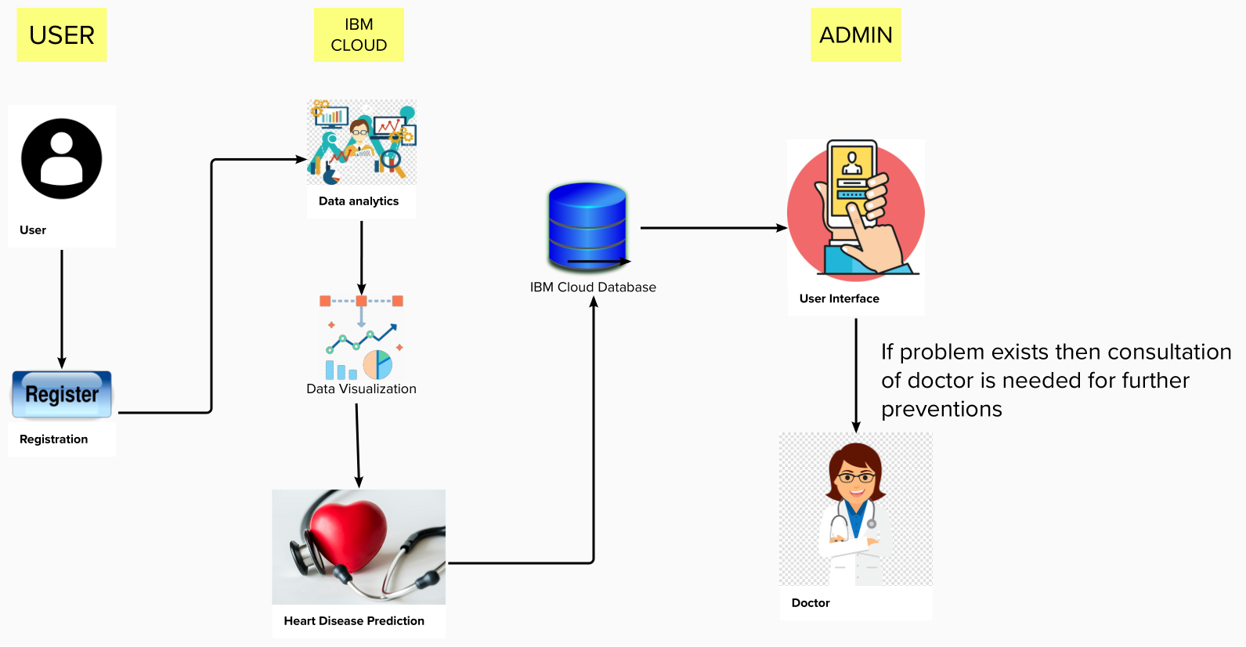

**Table-1 : Components & Technologies:**

| **S.No** | **Component** | **Description** | **Technology** |
| --- | --- | --- | --- |
|  | User Interface | How user interacts with application e.g.  Web UI, Mobile App, Chatbot etc. | HTML, CSS, JavaScript |
|  | Application Logic-1 | Logic for a process in the application | Python |
|  | Database | Data Type, Configurations etc. | MySQL |
|  | Cloud Database | Database Service on Cloud | IBM DB2 |
|  | File Storage | File storage requirements | IBM Block Storage or Other Storage Service or Local Filesystem |
|  | Machine Learning Model | Purpose of Machine Learning Model | Object Recognition Model, k-means, Decision Tree, Naïve Bayes. |
|  | Infrastructure (Server / Cloud) | Application Deployment on Local System / Cloud  Local Server Configuration:  Cloud Server Configuration : | Local, Cloud Foundry, Kubernetes, etc. |

**Table-2: Application Characteristics:**

| **S.No** | **Characteristics** | **Description** | **Technology** |
| --- | --- | --- | --- |
|  | Open-Source Frameworks | List the open-source frameworks used | IBM Cognos Analytics |
|  | Security Implementations | List all the security / access controls implemented, use of firewalls etc. | Security provided by cloud |
|  | Scalable Architecture | Justify the scalability of architecture (3 – tier, Micro-services) | IBM Cognos Analytics |
|  | Availability | Justify the availability of application (e.g. use of load balancers, distributed servers etc.) | IBM Cloud Services |
|  | Performance | Design consideration for the performance of the application (number of requests per sec, use of Cache, use of CDN’s) etc. | Reliable Data classification models |